# Food Justice Workshops & Fresh Stop Training Institute

* [Home](https://newroots.org/)
* Food Justice Workshops & Fresh Stop Training Institute

#### **Food Justice Workshops, Fresh Stop Training Institute (FSTI), and Canvassing!**

Here is the 2018 Organizing Schedule. Join the movement!

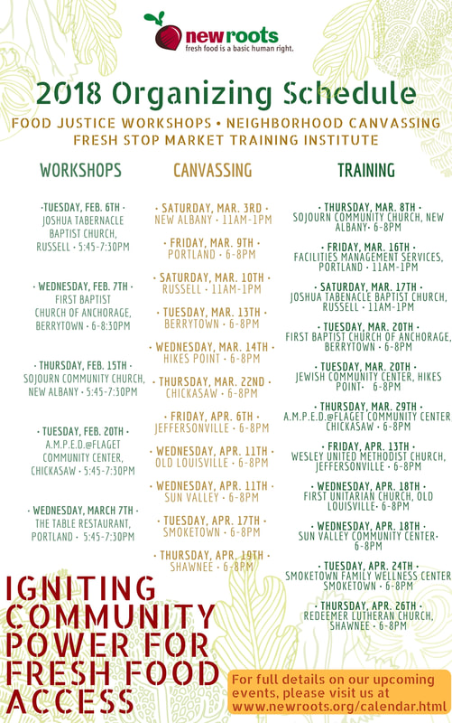

Check out the poster above for our 2018 dates.

Questions? Email us at info@newroots.org

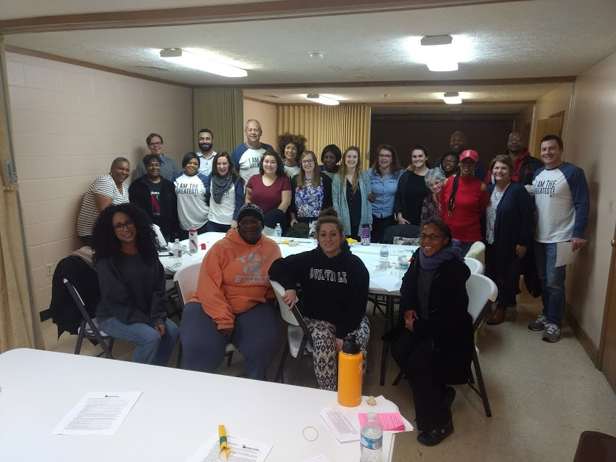

What a beautiful crowd! Some of our leaders and community members from the Russell neighborhood joined us for the 2018 Russell Food Justice Workshop at Joshua Tabernacle Baptist Church

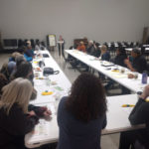

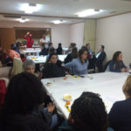



#### **What are Food Justice Workshops and the Fresh Stop Training Institute?**

​New Roots Food Justice Workshops utilize popular democracy to share food stories, have in-depth discussions on the root causes of food insecurity and food apartheid, and build strength and excitement around creating an alternative way to feed ourselves, our families and our community, while at the same time helping our rural farmers. These workshops can be life changing as you learn and share about the histories of our communities that have been historically red-lined and experienced decades of disinvestment. Together we find a common purpose to make real social change.

The Fresh Stop Training Institute (FSTI) is a pay-it-forward coaching program focused on developing neighborhood leaders who create, implement, and sustain their own solutions for increasing food security in their communities. Calling on the experiences of seasoned Fresh Stop Market leaders, FSTI sessions cover topics such as price negotiation, ordering, forecasting, community organizing, Microsoft Office/Google Drive, chef recruitment, “day of” Fresh Stop Market operations, Beet Beat Magazine themes of the year, and other subjects that leaders choose.